|  |  |
| --- | --- |
|   **Enterprise web Software development – Comp1640** | group 12  *HUYNH NGOC PHUONG ANH – GCS190288 NGUYEN THAI TUAN – GCS18661*  *PHAM MINH CHIEN – GDS18025*  *TRAN DIEP QUOC TRUNG – GCS18792* |

Table of Contents

**1.** **Introduction** 2

**2.** **Requirement Engineering** 3

**2.1.** **Roles and Functions** 3

**2.2.** **Use Case Diagram** 10

**2.3.** **Activity Diagram** 12

**2.4**  **Sequence Diagram** 17

**3.** **Database Design** 21

**4.** **User Interface Design** 23

**5.** **Testing** 25

**6.** **Agile Method** 30

**6.1.** **Product Backlogs** 30

**6.2.** **Sprints** 30

**6.3.** **Schedule Meetings** 32

**6.4.** **Burndown Charts** 32

**7.** **Product Deployment** 34

**8.** **Evaluation** 35

**8.1.** **Product Assessment** 35

**8.2.** **Process Assessment** 35

**8.3.** **The Whole Team Assessment** 35

**9.** **Link** 36

**10.** **References** 37

1. **Introduction**

Our project is going to focus on building a company's internal website to collect ideas from staff and the main purpose is to encourage them to express their point of view. More specifically, this website is similar to a forum where everyone can give their ideas about a certain topic within a certain period is set up by the admin.

This project will use agile scrum working practices to divide work into four sprints. Each sprint has two weeks to finish the assigned work. This method will help us control the amount of work. Everyone has responsibility for their tasks so that if there is something, we know the problem came from.

To have a more specific view of our project, take a look at the project requirements that we have to reach:

* Four main roles: Quality Assurance Manager, QA Coordinator, Administrator, and Staff.
* The Quality Assurance Manager can supervise the procedure, create/read/update/delete (CRUD) categories and download all the files after the final closure date.
* QA coordinators can manipulate the process for their department.
* Staff must agree to Terms and Conditions before submitting ideas, upload files or documents to support their ideas, comment on other ideas, and select once for the thumbs up or thumbs down for any ideas. They can be posted anonymously, but their author details will still be saved in the database. Send email and receive an email notification whenever comments or ideas are submitted.
* Administrators have all the functions above to maintain any system data, set closure dates for each academic year, staff details, etc.
* Statistical analysis will be shown up in the dashboard of authorized senior accounts.
* The interface must be fit for all devices.

1. **Requirement Engineering**
   1. **Roles and Functions**

This system will have four main roles: Quality Assurance Manager, QA Coordinator, Administrator, and Staff.

* + 1. **User Class – Administrator**
       1. **Functional Requirement 1.1**

**ID:** FR1

**Feature:** Administrator login

To administer the system, an administrator should be logged in to the web portal.

**Scenario:** Successful log-in

Given the administrator wants to log in

When the administrator logs in with an administrator account

Then the administrator should be logged in as an administrator

* + - 1. **Functional Requirement 1.2**

**ID:** FR2

**Feature:** Manage Category

To manage the category, the system, an administrator should be logged in to the web portal.

**Scenario:** Create New Category

Given the administrator wants to log in

When the administrator creates a new one, then the information should be added to the database and shown on Category’s index page.

When users create a new idea, they need to pick one category to categorize those ideas.

**Scenario:** Edit Category

When the administrator edits a new one, then the information should be updated to the database.

**Scenario:** View Category

When the administrator views a specific one, then navigate to the category detail page.

**Scenario:** Delete Category

When the administrator deletes one, all the information related to that category must be removed.

* + - 1. **Functional Requirement 1.3**

**ID:** FR3

**Feature:** Manage Department

To manage a department in the system, an administrator should be logged in to the web portal.

**Scenario:** Create New Department

Given the administrator wants to log in

When the administrator creates a new one, then the information should be added to the database and shown on the Department index page.

When the admin adds new a user, he needs to pick one department to categorize those users.

**Scenario:** Edit Department

When the administrator edits a new one, then the information should be updated to the database.

**Scenario:** View Department

When the administrator views a specific one, then navigate to the department detail page.

**Scenario:** Delete Department

When the administrator deletes one, all the information related to that department must be removed.

* + - 1. **Functional Requirement 1.4**

**ID:** FR4

**Feature:** Manage Topic Submission

An administrator should be logged in to the web portal to manage topic submission in the system.

**Scenario:** Modified Closure Dates

Admin will hold the key to lock or unlock the date of submission idea, which means they have the right to open the date or close it.

**Scenario:** View All Ideas Belong to That Topic.

* + - 1. **Functional Requirement 1.5**

**ID:** FR5

**Feature:** View Statical Analysis

To view the statistical analysis in the system, an administrator should be logged in to the web portal.

* + 1. **User Class – Staff**
       1. **Functional Requirement 1.1**

**ID:** FR1

**Feature:** Staff login

To use functions and access the idea page in the system, staff should be logged into the web portal.

**Scenario:** Successful log-in

* + - 1. **Functional Requirement 1.2**

**ID:** FR2

**Feature:** Manage Ideas

To manage ideas, staff should be logged in to the web portal.

**Scenario:** Post idea, Upload Document, Add Idea To Category

Staff access to topic submission at first, then use the post idea function to submit it.

**Scenario:** Delete idea

Staff can delete their ideas.

**Scenario:** View idea

Staff can view their ideas and others' ideas.

**Scenario:** Add Comment and Reply Comment to An Idea.

Staff access idea page details to give comments and reply to others.

**Scenario:** Add Reaction to An Idea.

Each member of staff can only like or dislike it once.

**Scenario:** Receive an Automatic Email Notification.

Staff will be notified via email whenever anyone comments on their ideas.

* + - 1. **Functional Requirement 1.3**

**ID:** FR3

**Feature:** Manage Account

Staff should be logged in to the web portal to manage an account.

**Scenario:** Upload Profiles

Staff can upload their profile.

* + 1. **User Class – Manager**
       1. **Functional Requirement 1.1**

**ID:** FR1

**Feature:** Manager login

To use functions and access to idea page in the system, a manager should be logged in to the web portal.

**Scenario:** Successful log-in

* + - 1. **Functional Requirement 1.2**

**ID:** FR2

**Feature:** Manage Ideas

To manage ideas, a manager should be logged in to the web portal.

**Scenario:** Post idea, Upload Document, Add Idea To Category

Managers access topic submission at first, then use the post idea function to submit it.

**Scenario:** Delete idea

Managers can delete their ideas.

**Scenario:** View idea

Managers can view their ideas and others’ ideas.

**Scenario:** Add Comment and Reply Comment To An Idea.

Managers have access to idea page detail to give comments and reply to others.

**Scenario:** Add Reaction To An Idea.

Each Manager can only like or dislike once.

**Scenario:** Download Files.

All files uploaded will be downloaded automatically after the final closure date.

**Scenario:** Receive An Automatic Email Notification.

Managers will be notified via Email when anyone comments on their ideas.

* + - 1. **Functional Requirement 1.3**

**ID:** FR3

**Feature:** Manage Account

To manage an account, a manager should be logged in to the web portal.

**Scenario:** Upload Profiles

Managers can upload their profiles.

* + - 1. **Functional Requirement 1.4**

**ID:** FR4

**Feature:** View Statical Analysis

To view the statistical analysis in the system, a manager should be logged in to the web portal.

* + - 1. **Functional Requirement 1.5**

**ID:** FR5

**Feature:** Manage Category

To manage categories in the system, a manager should be logged in to the web portal.

**Scenario:** Create New Category

Given the manager wants to log in

When the manager creates a new one, then the information should be added to the database and shown on Category’s index page.

When users create a new idea, they need to pick one category to categorize those ideas.

**Scenario:** Edit Category

When the manager edits a new one, then the information should be updated to the database.

**Scenario:** View Category

When the manager views a specific one, then navigate to the category detail page.

**Scenario:** Delete Category

When the manager deletes one, all the information related to that category must be removed.

* + 1. **User Class – Coordinator**
       1. **Functional Requirement 1.1**

**ID:** FR1

**Feature:** Coordinator login

To use functions and access the idea page in the system, a Coordinator should be logged in to the web portal.

**Scenario:** Successful log-in

* + - 1. **Functional Requirement 1.2**

**ID:** FR2

**Feature:** Manage Ideas

To manage ideas, a Coordinator should be logged in to the web portal.

**Scenario:** Post idea, Upload Document, Add Idea to Category

Coordinators have access to topic submission at first, then use the post idea function to submit it.

**Scenario:** Delete idea

Coordinators can delete their ideas.

**Scenario:** View idea

Coordinators can view their ideas and others' ideas.

**Scenario:** Add Comment and Reply Comment to An Idea.

Coordinators access the idea page details to give comments and reply to others.

**Scenario:** Add Reaction to an Idea.

Each coordinator can only like or dislike once.

**Scenario:** Receive an Automatic Email Notification.

Coordinators will be notified via email whenever anyone comments on their ideas.

* + - 1. **Functional Requirement 1.3**

**ID:** FR3

**Feature:** Manage Account

To manage an account, a Coordinator should be logged in to the web portal.

**Scenario:** Upload Profiles

Coordinators can upload their profiles.

* + - 1. **Functional Requirement 1.4**

**ID:** FR4

**Feature:** View statistical Analysis

To view the statistical analysis in the system, a Coordinator should be logged in to the web portal.

.

* 1. **Use Case Diagram**

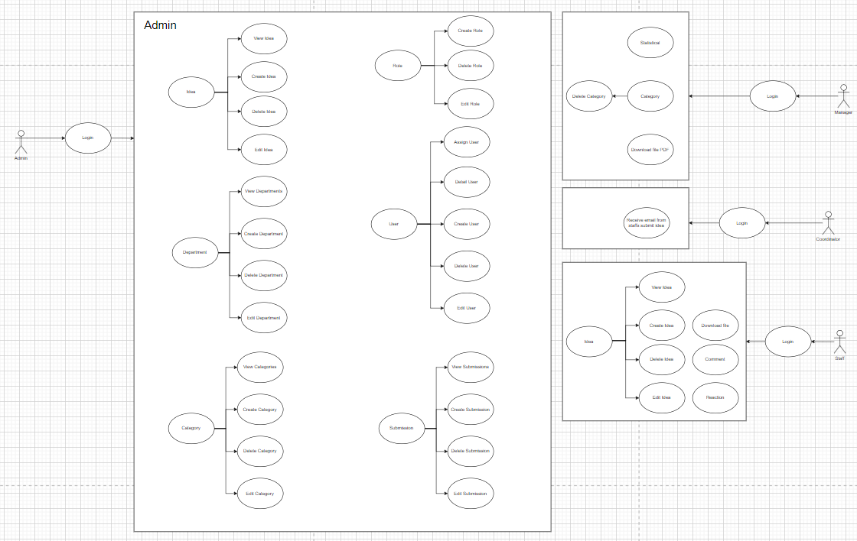

*Figure 1: Use Case Diagram*

**Admin:**

Based on the diagram, we can see that the admin has the right to create services, and categories, decentralize all users and create submissions. The features that the administrator manages can only be used by the administrator and these functions, moreover, help the administrator to run the whole system. Below I will describe this feature in more detail.

The admin creates a department with the purpose that while registering a user, the admin can choose and assign that employee to the right department position, in addition, the admin can manage the department and perform CRUD tasks.

The admin creates a category to contain the submissions, additionally, the admin can manage the category and perform CRUD tasks.

Administrators create roles to decentralize users. Additionally, the admin can manage roles and perform CRUD tasks.

The admin creates a submission for the purpose that the staff can contribute ideas to the submissions, additionally, the admin can manage the submission and perform CRUD tasks.

**Manager**

The manager plays the role of an idea manager, the manager can delete the categories if the category is empty. In addition, the manager can also monitor the number of idea statistics, the manager can download these idea files in PDF format.

**Staff**

The staff can submit their ideas to the system with a document file if any, before completing the submission they have to select an input box to accept or not. Additionally, staff can post the idea anonymously. Once the idea has been posted on the system, people can go there and like or dislike the idea and can leave their comments anonymously or publicly. The special thing about our comments is that people who come later can reply to all these emails. Finally, the user receives an automatic email after submitting the idea.

**Coordinator**

The coordinator plays the role of motivating employees to submit ideas to the system.

* 1. **Activity Diagram**

**Admin**

*Figure 2: Admin Activity Diagram*

Admin diagram, to access with admin rights, you must first log in to the correct account that has admin rights. After the admin successfully logs into the admin page, the functions will be fully displayed including Department, Category, Role, Submission. When administrators want to manipulate a service's data, all they need to do is access the appropriate service function, they have CRUD rights in the service. Similar to the category, the admin only needs to access the correct category function, then he has CRUD rights in the category. Similar to the role, the administrator only needs access to the right role function, then he has the CRUD permission in the role. Similar to Submission, the admin only needs to access the correct submission function, then he has the CRUD permission in the submission.

**Staff**

*Figure 3: Staff Activity Diagram*

Diagram of the employee, the employee must first access the employee account correctly and the system will check whether this user account exists or not, in case it does not exist, it will report an error to the user, in the right case will allow the user to perform operations related to employee rights. Employees have 2 parts: the first part is to submit ideas. Employees have the right to submit ideas anonymously or publicly, agree to the terms before submitting, and then complete submitting ideas. The second part is to visualize ideas, employees can visualize ideas and manipulate likes and comments to terminate the operation.

**Manager**

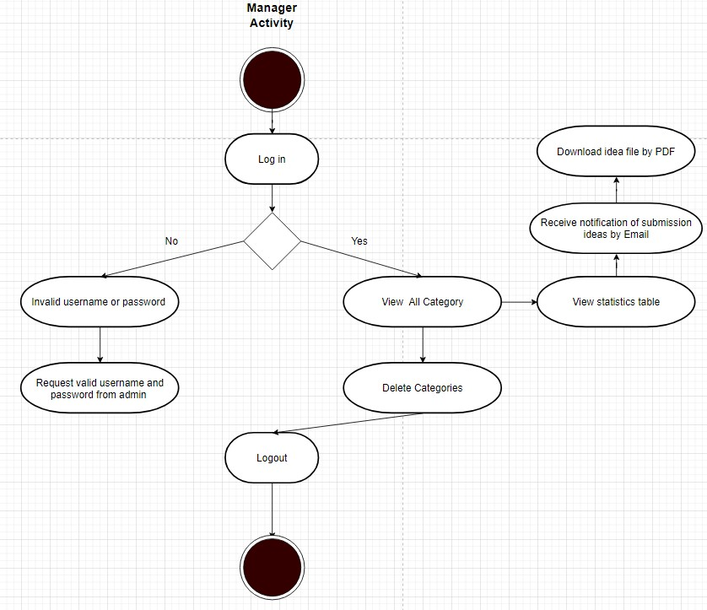

*Figure 4: Manager Activity Diagram*

Diagram Manager, the employee must first access the Manager account correctly and the system will check whether this user account exists or not, in case it does not exist, it will report an error to the user, in the case of the correct match will allow the user to perform operations related to the permissions of the manager. The manager has 3 parts: The first part is to see the statistics and complete the operation, the second part is to download the file with pdf and complete the operation, and the third part is to receive an automatic email when someone submits the article and finish. to create

**Coordinator**

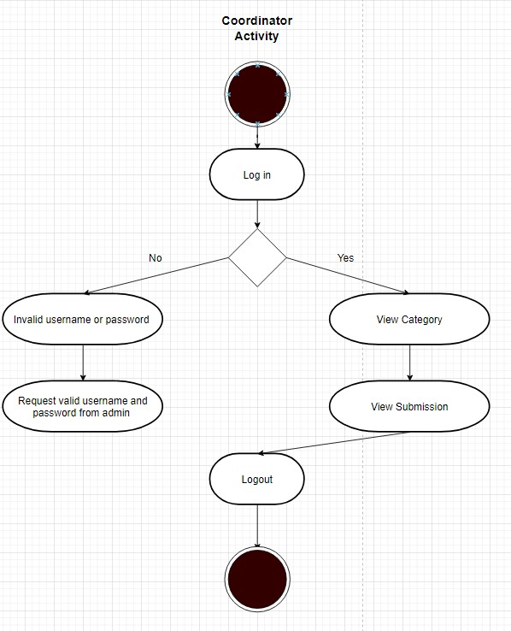

*Figure 5: Coordinator Activity Diagram*

Diagram coordinator, the coordinator must first access the Manager account correctly and the system will check whether this user account exists or not, in case it does not exist, it will report an error to the user, in the case of the correct match will allow the user to perform operations related to the permissions of the coordinator. The task of the coordinator part is to see the statistics and remind staff to submit their ideas to the system.

## **2.4** **Sequence Diagram**

**Admin**

*Figure 6: Admin Activity Diagram*

In this diagram, Admin logs in by using admin accounts. The authentication will determine whether the user is an administrator or not. If it is correct, the admin account will be confirmed; otherwise, it will return to the login page and report an error indicating that the login failed. After the verification is finished, the admin navigates to the pages that are under their right. Then, the admin can add a new user, set a closure date, and control data in the database.

**Staff**

*Figure 7: Staff Sequence Diagram*

Employee activity diagram, before entering the main function, it is necessary to log in to the system. Staff is only allowed to submit ideas, so go to the submission and submit ideas. Staff submit an idea but can leave it anonymous, other staff can enter the idea and post comments and rate the idea by commenting.

**Coordinator**

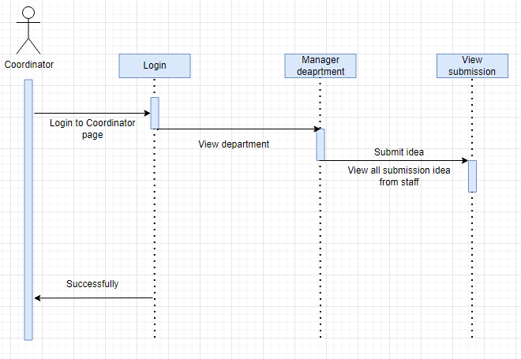

*Figure 8: Coordinator Sequence Diagram*

Coordinator operation diagram, before entering the main function, they need to log in to the system. Upon successful completion, they perform the task of monitoring the process of the busy department to which they are attached.

**Manager**

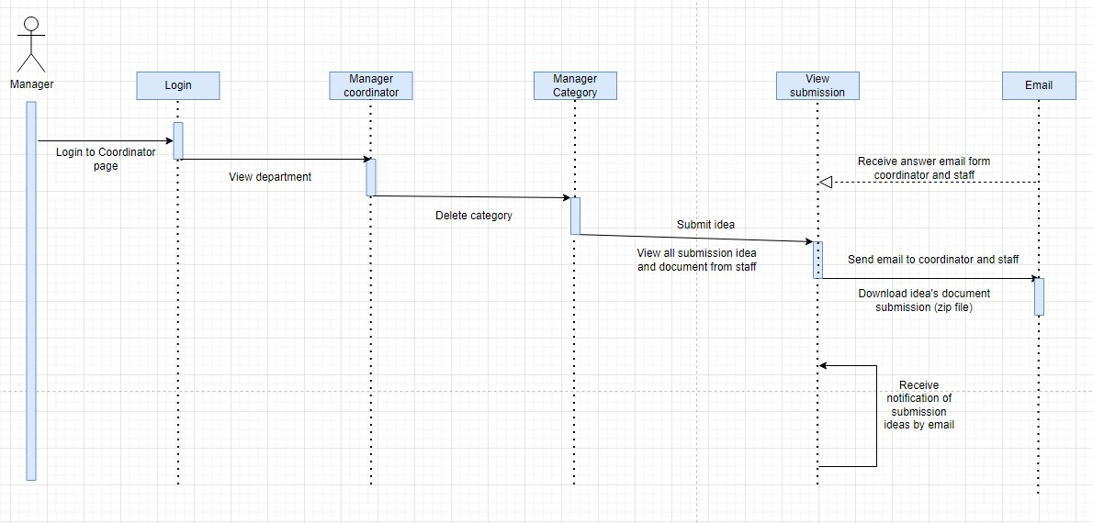

*Figure 9: Manager Sequence Diagram*

Manager operation diagram, before entering the main function, they need to log in to the system. Upon successful completion, the Manager performs specific tasks such as managing Manage submitted ideas, deleting categories, and receiving and responding to emails when staff submits their ideas. In addition, the manager can also download the idea document as a PDF file.

1. **Database Design**

**UML Diagram**

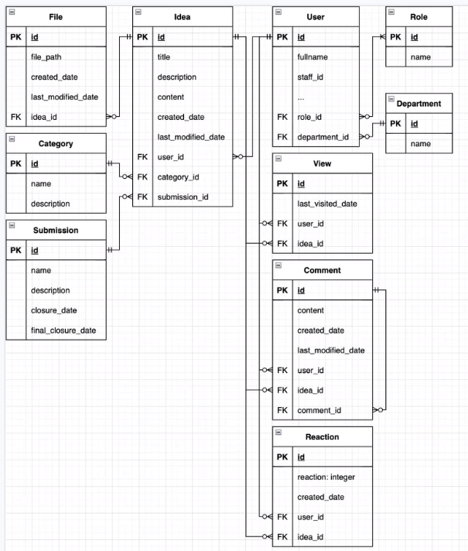

*Figure 10: ERD Diagram*

*Figure 11:UML Diagram*

1. **User Interface Design**

**Home page**

**Login Page**

1. **Testing**

**Test Case**

|  |  |  |  |  |  |
| --- | --- | --- | --- | --- | --- |
| **No.** | **Function** | **Test Way** | **Expected Results** | **Test Date** | **Final Results** |
| 1 | Login | Enter Username and Password and click the “Sign in” button on the Login page | Navigate to the Homepage. The username will show up on the right of the navbar. | 2/4/2022 | Passed |
| 2 | Logout | Enter the “Logout” button on the home page. | _ Still on the homepage.  _ Cannot access any page until Login. | 2/4/2022 | Passed |
| 3 | Return homepage to the Login page | Click the Logo University of Greenwich on top of the Login Box. | Return to home page. | 2/4/2022 | Passed |
| **Login As Admin** | | | | | |
| 3 | Add New User | Input username, password, staff, first name, last name, address, email, department, sex, DOB and click Register | Alert Success | 2/4/2022 | Failed |
| 4 | Create New Category, Department | Input each piece of information and click the Create button. | _ Success then returns the Category’s Index to show the list and the new one has created is added to the database.  _ Error then shows an error notification  _ The Department is similar. | 2/4/2022 | Passed |
| 5 | Edit Category, Department | Edit function will be shown up on the right side of the specific category on the Category’s Index page.  Edit function will also be on the Category Detail page.  Department function is similar. | Show all the information and the save button. | 2/4/2022 | Passed |
| 6 | View Category, Department | The view Detail function will be next to the Edit button. | Show all the information after creating or editing. | 2/4/2022 | Passed |
| 7 | Delete Category, Department | The delete function will be next to the View button. | All the related information will be removed from the database | 2/4/2022 | Passed |
| 8 | Create Topic Submission | Input topic name, description, set up closure date, and final closure date. | _ Success then returns Submission’s Index to show the list and the new one has created is added to the database.  _ Error then shows error notification. | 2/4/2022 | Passed |
| 9 | Edit Topic Submission | Edit function will be shown up on the right side of the specific submission on the Submission’s Index page.  Edit function will also be on Submission’s Detail page. | Show all the information and the save button. | 2/4/2022 | Passed |
| 10 | View Submission | The view Detail function will be next to the Edit button. | Show all the information after creating or editing. | 2/4/2022 | Passed |
| 11 | Delete Submission | The delete function will be next to the View button. | All the related information will be removed from the database | 2/4/2022 | Passed |
| **Login as Staff** | | | | | |
| 12 | Post Idea | Input title, description, content, select dropdown list, check to agree to the term and check anonymous type. | _ Success then returns Idea’s Index to show the list and the new one has created is added to the database.  _ Error then shows error notification. | 2/4/2022 | Passed |
| 13 | Editing Idea | Only input title, description, and content. | _ Success then return Idea’s Index to show the list and the edited data and modified date will be updated to the database.  _ Error then show error notification. | 2/4/2022 | Passed |
| 14 | View Idea | The view Detail function will be next to the Edit button. | Show the information after creating or editing.  Show Comment function and all of the users commented.  Show Like/Dislike function and number of like and dislike. | 2/4/2022 | Passed |
| 15 | Delete Idea | The delete function will be next to the View button. | All the related information will be removed from the database | 2/4/2022 | Passed |
| 16 | Comment on a specific Idea Page. | Input the message and check whether anonymous or not. | _ Success then returns Idea’s Detail page and shows all the comments.  _ The new comment will be added to the database with UserId.  _ Error then show error notification. | 2/4/2022 | Passed |
| 17 | Reply comment on a specific Idea Page | Click Reply Button and show the Input message with a checkbox to choose whether anonymous or not. | _ Success then returns Idea’s Detail page and shows all the comments.  _ The new reply comment will be added to the database with UserId.  _ Error then show error notification. | 2/4/2022 | Passed |
| 18 | Like/Dislike Button in specific Idea Page. | One user can only like or dislike once. | _ If the user hasn’t liked it yet, add one like to the database when they click Like.  _ If the user clicks Dislike but Like already exists, update Like to Dislike.  _ If the user clicks Dislike but Dislike already exists, remove Dislike. | 2/4/2022 | Passed |

1. **Agile Method**
   1. **Product Backlogs**

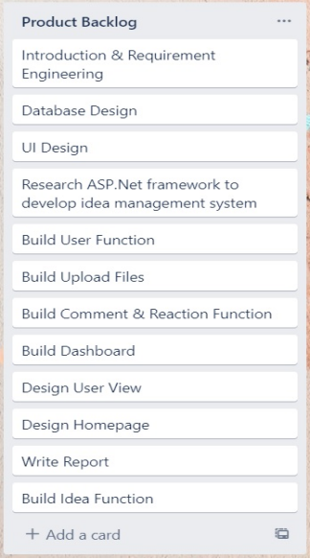

*Figure 12 Product backlog*

* 1. **Sprints**

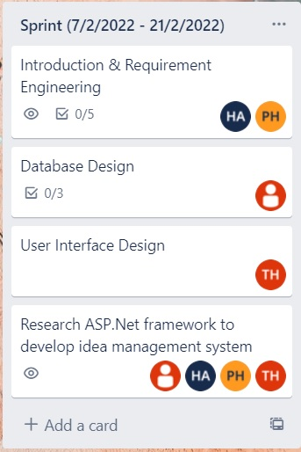

*Figure 13: Sprint 1*

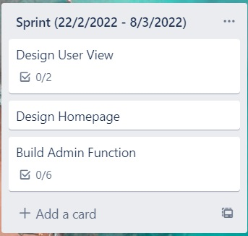

*Figure 13 Sprint 2*

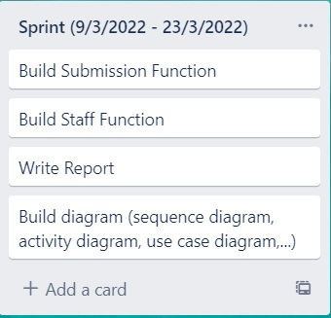

*Figure 14: Sprint 3*

* 1. **Schedule Meetings**

* 1. **Burndown Charts**

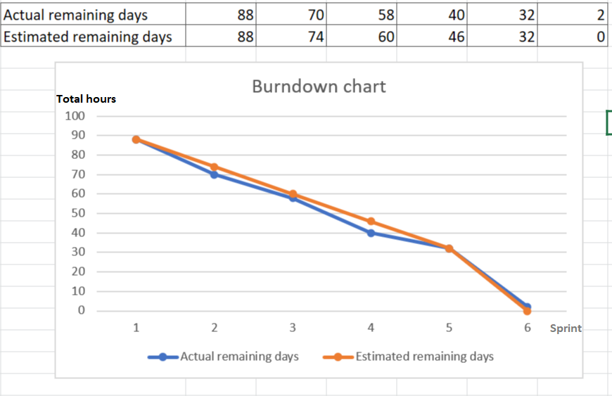*Figure 15: Burndown Charts*

1. **Product Deployment**

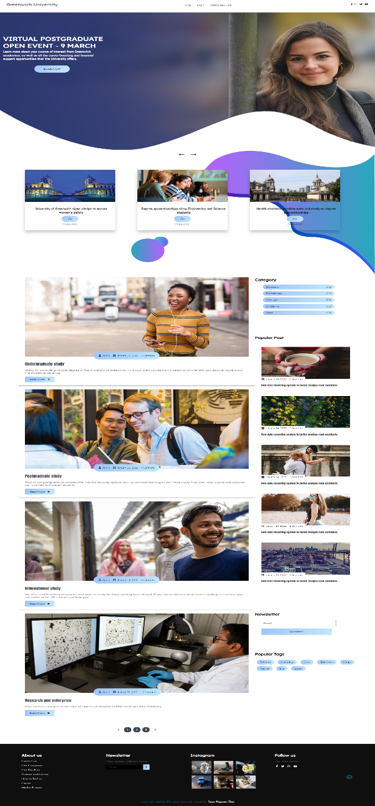

Home page

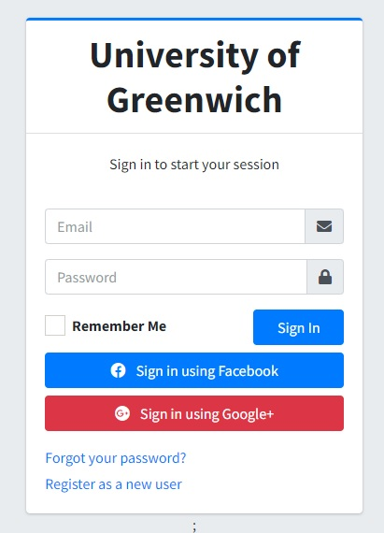

Login Page

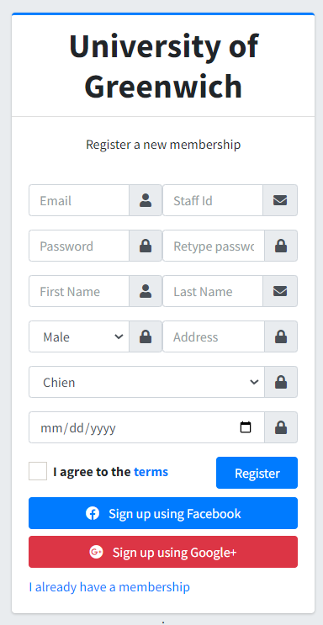

Create account page

**Admin**

Department

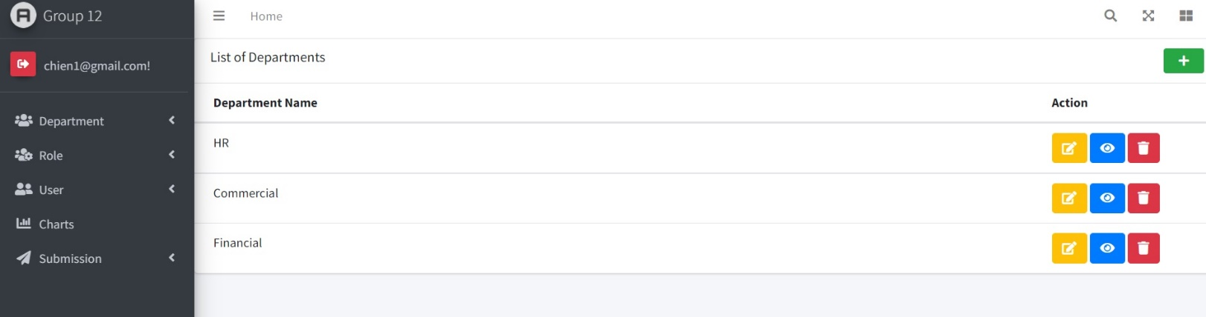 Department page

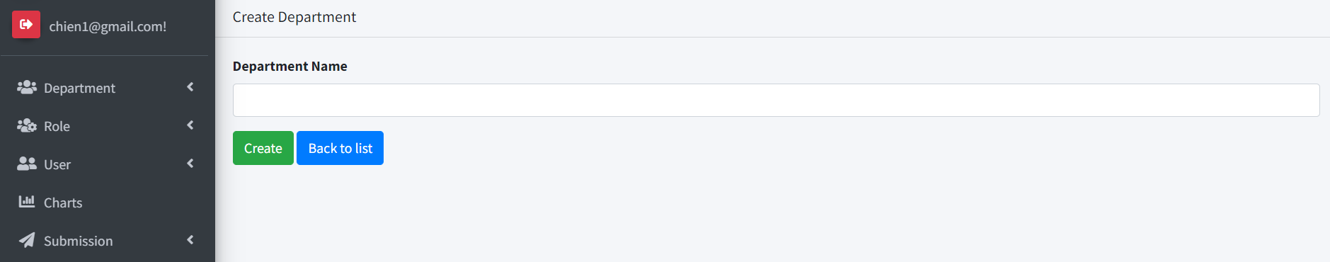 Create department page

Role

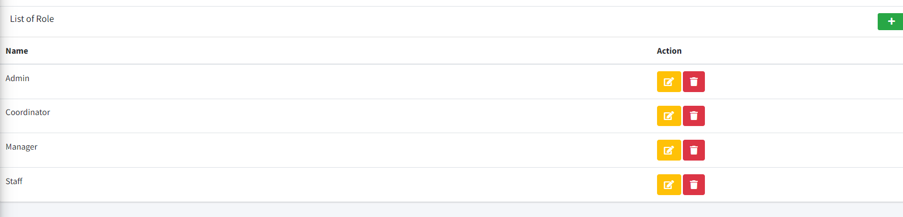 List of role page

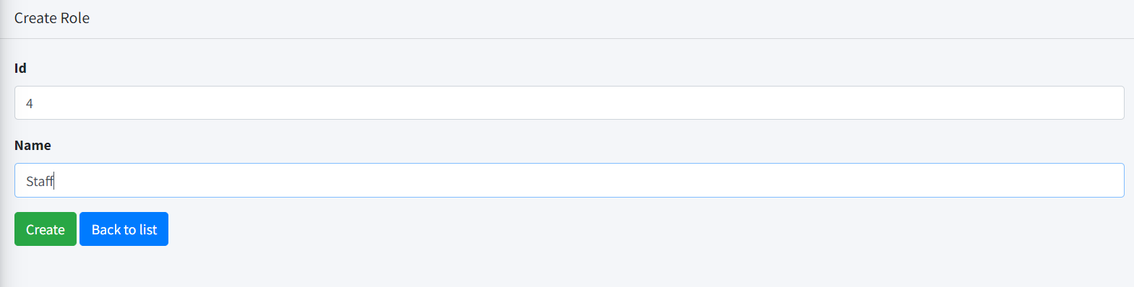 Create role page

User

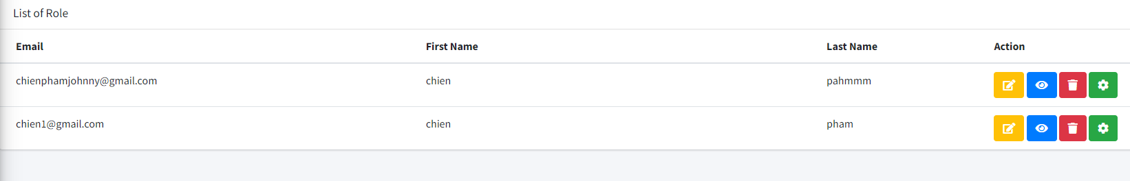 List of user page

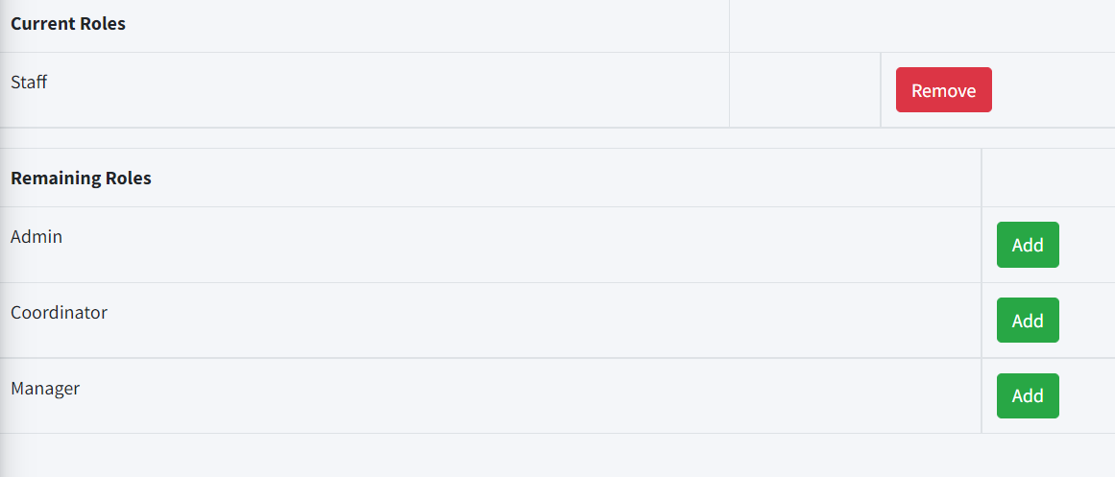

Adding role to user page

Statistical analysis chart

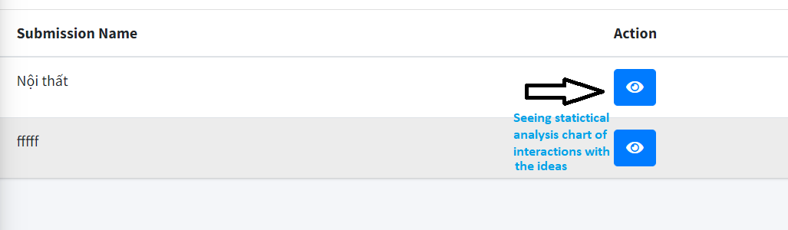 Submission page

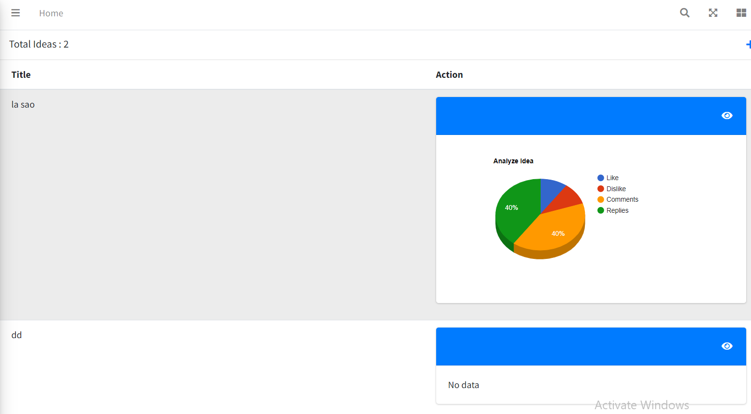 Statistical analysis chart

Submission page

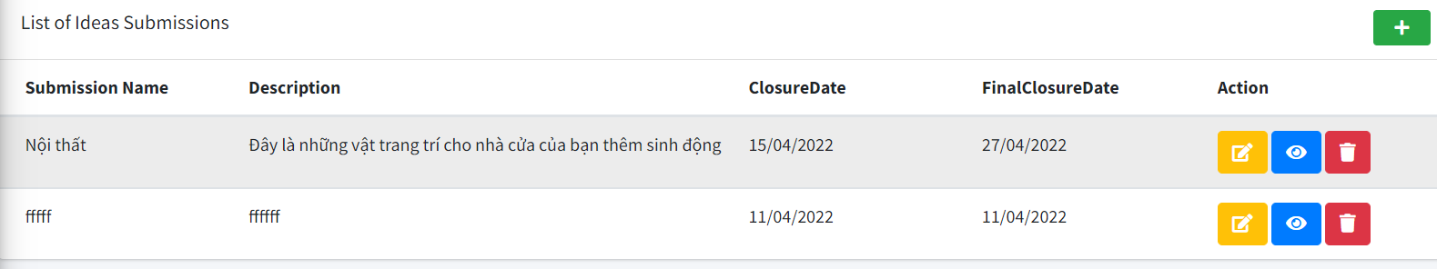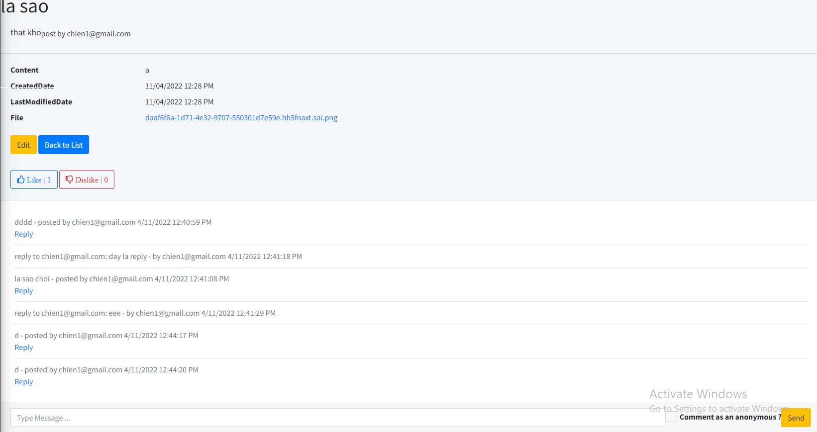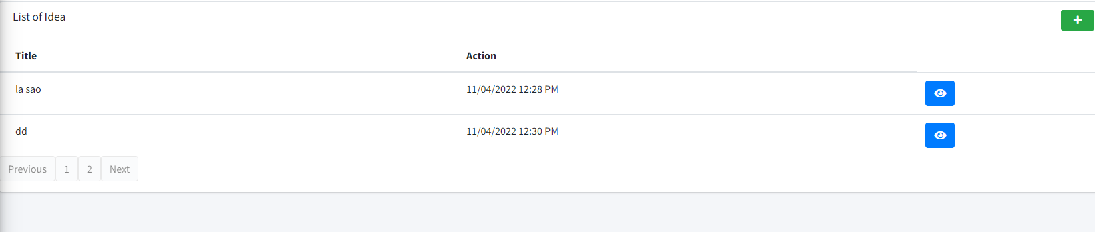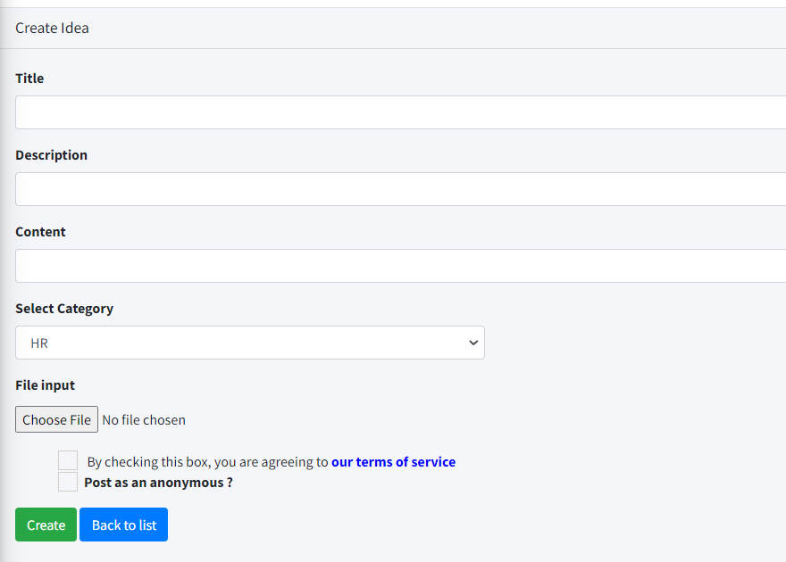

**Evaluation**

* 1. **Product Assessment**
  2. **Process Assessment**

During the entire project implementation, to complete the project on time, our team decided to use the Scrum model to help manage the project time in an organized way. Specifically, it breaks our project down into parts, the breakdown helps team members focus on completing the work in that part.

So, the work will not be lacking, in this project, we have about three months to complete, we started the project on 02/07/2022 to 04/07/2022. Our team accepted and divided it into 4 sprints: Sprint 1 (February 7, 2022 - February 21, 2022) Sprint 2 (February 22, 2022 - March 8, 2022) Sprint 3 (March 9, 2022 - March 23, 2022) Sprint 4 (April 7, 2022 - April 14, 2022).

Before leaving the sprint, our team will list all the functions, then divide them into each specific sprint, each workload will be less after each sprint. The work that remains in the sprint will be selected by team members based on their abilities and to meet the deadline. Using Scum, the leader was able to motivate team members to work more efficiently, and everyone showed effort throughout the project process.

Every framework has its strengths and weaknesses and Scrum is no exception. This is the first time that our team has applied Scrum to the development of a project, so there are many points where our team has not yet adapted and has not mastered the use of the framework. We had to create meetings regularly, but for objective reasons, it became difficult to organize a meeting to solve problems collectively. Also, to achieve the greatest efficiency when using Scrum, team members should have equal skill sets, if one or two members are not experienced enough, it can cause delays for the entire team. project. Therefore, it is necessary to have experienced people to lead and support to overcome these shortcomings. In short, the efforts of each team member and the adoption of the Scrum framework helped us complete the project on time.

* 1. **The Whole Team Assessment**

Before forming the team, we imagined and agreed on several operating principles within the group. The first principle is always to listen and give your point of view to contribute constructively to the work process. The second principle is fairness in the distribution of tasks. The final rule is to always be ready to help other team members when they have problems.

We applied these principles for 3 months from the project start date, everyone's feedback is given continuously and is welcomed by all opinions, on the work attitude of everyone in the group, supplementing always seriously assigned work Tasks. The process of dividing the tasks into several tasks always guarantees fairness. Moreover, our team always creates comfort for all members to choose the work they can take on, the tasks. If no member accepts, the whole group will work together. Problems encountered during the project will be discussed in 5-minute meetings every evening, members who have problems will be noted and included in the weekend time for the whole group to sit down and solve them together. In short, all the members put their best effort into this project

1. **Link**

**Trello:**

[https://trello.com/invite/b/bF99OKNg/0b58130c169cbea89228361135a0b07a/web-enterprise](https://l.facebook.com/l.php?u=https%3A%2F%2Ftrello.com%2Finvite%2Fb%2FbF99OKNg%2F0b58130c169cbea89228361135a0b07a%2Fweb-enterprise%3Ffbclid%3DIwAR0HH0ym2drECrQwGmPXXlrilLd75IUrRwGGkZmUc9GtxBiaFGYyZSVycB4&h=AT0BRTuW4snJRhMHSqHPS8wOIDga0ZTthhsUv4fCrgPoEMVTJCI-9ExuY3KJl-tdHOfSsz8VT8ImNRPd8fXstLCVQ4_76KTlrKjPilFX_EgOB5SUU2Ydrq0t-bMaTgW4pNjkxg)

**Collaboration with Visual Studio Live Share:**

<https://visualstudio.microsoft.com/services/live-share/>

**MS Team:**

<https://teams.microsoft.com/l/team/19%3a6OTZ2sE8LvxDITgAywm3LNQn1clvm1wSWl-eDN4jXpw1%40thread.tacv2/conversations?groupId=e91fbbfc-36c1-4108-865d-0c4a3173a1ac&tenantId=848ca557-8755-48d4-94fd-01746f8537bc>

**Video Demo:**

**Source project (Git and driver):**

**Git:**

**Driver:**

1. **References**